Debugging with google chrome browser
Chrome, like many other browsers will run programs in HTML, Javascript and probably a few I don't know.
For some of us, knowing the words and the symbols is needed to use such facilities.
Start with the HTML page on screen. The HTML page calls in the Javascript, the Cascading styl sheets and maybe some more. Having displayed the page, right click on the mouse and select 'inspect' to call the debug tools. An example follows:
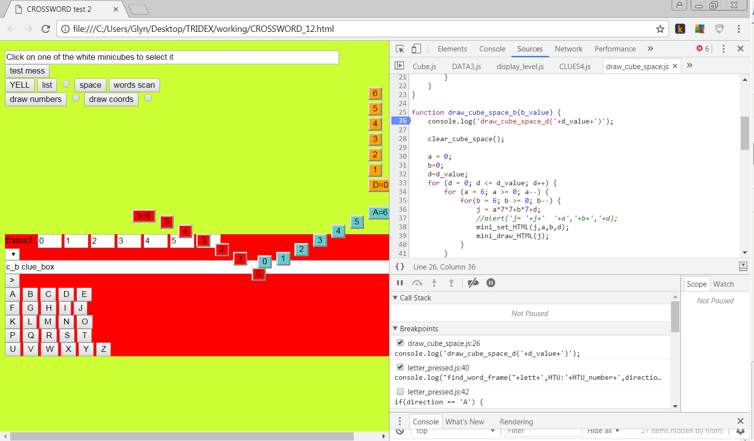
The left side of the screen is my HTML page, the right side the google chrome browser.
Looking at the top of the chrome browser are:-
▲ ▲ ❶ ❷ ❸ ❹ ❺ ❻ ❼ ❽ ❾
Toggle device toolbar. Rather that I try to explain it, try it!
❶ Select an element on a page to inspect it.

Elements
❷ Console
❸ Sources
❹ Network
❺ Performance
https://developers.google.com/web/updates/2016/12/devtools-javascript-cpu-profile-migration
❻>> A double arrow to give access to
Memory
Application
Security
Audits
❼ In my example there is a red circle with a cross in it to indicate an error somewhere. The number 6 indicates that the error has occurred 6 times.
❽ The 3 dots downwards is for Customize and control Devtools
❾and of course the X to close.
Going down a line we see:
[>] Show navigator. Clicking on it opens options
Sources
>> to open
Content scripts
Snippets
Then [<] to hide navigator
Then follows filenames of some of the programs in the project. One can select from these headings or from the navigator.
Finally >> to list all the other files in the project.
Next down comes the source code for the programs followed by the debug line. In the example above, the debug line says {} ?????? followed by a switch [v] to turn the debug display off.

Problems
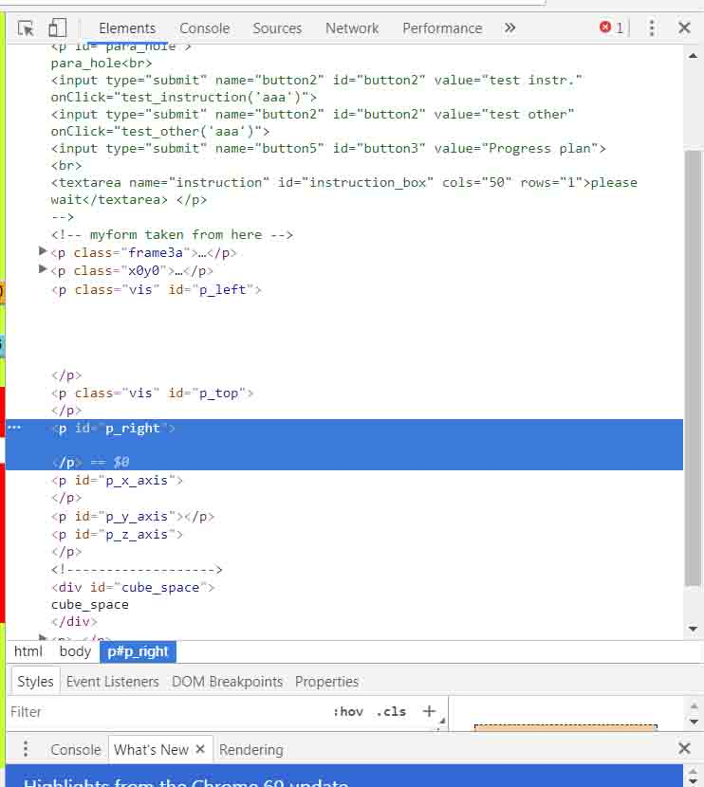
Problem 1
Need to reset

Looking at the line near the bottom (html body etc) it was draggable upwards revealing:
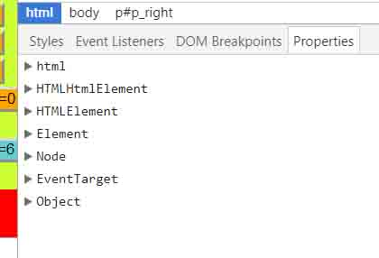

The p#p_right refers to an HTML paragraph with an id of p_right
html
HTMLhtmlElement
HTMLelement
ElementsNode
EventTarget
Object
Frame2

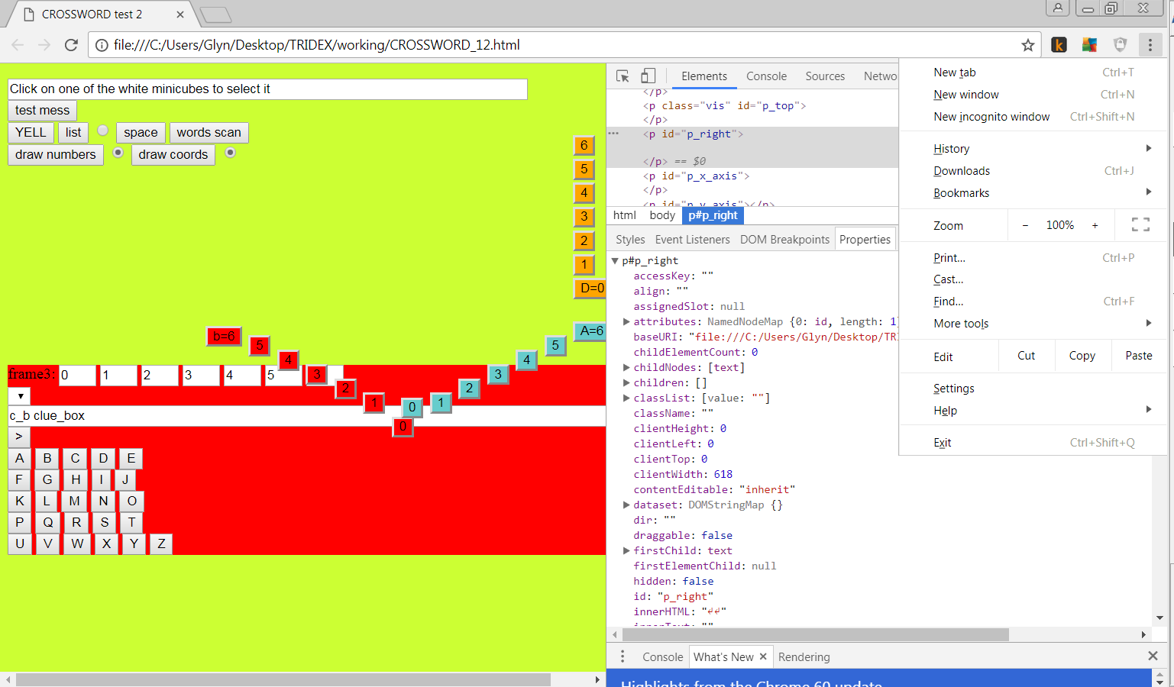
Frame3
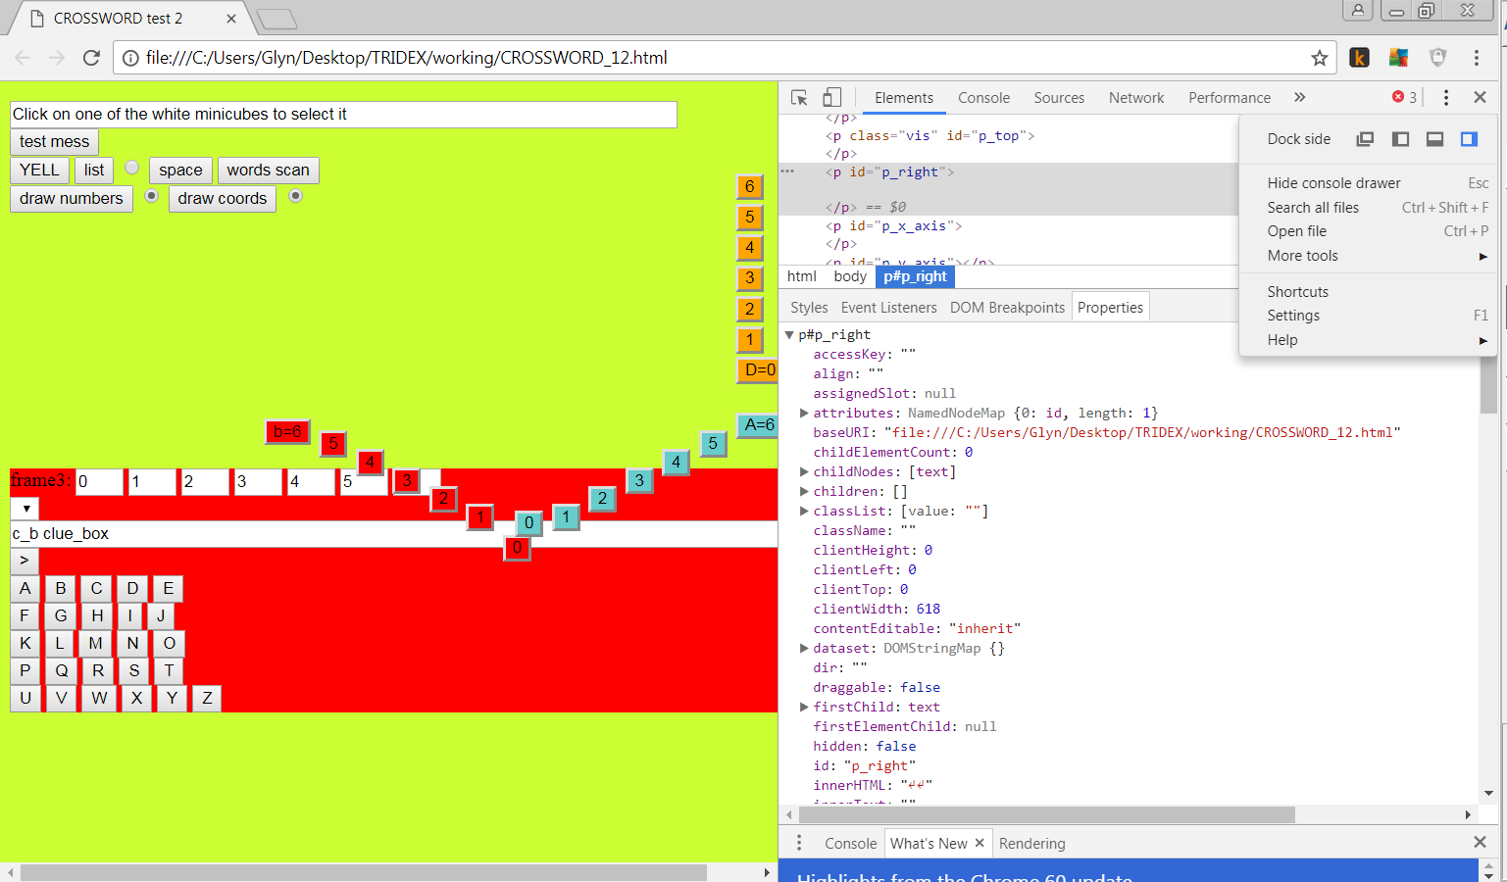
Frame4
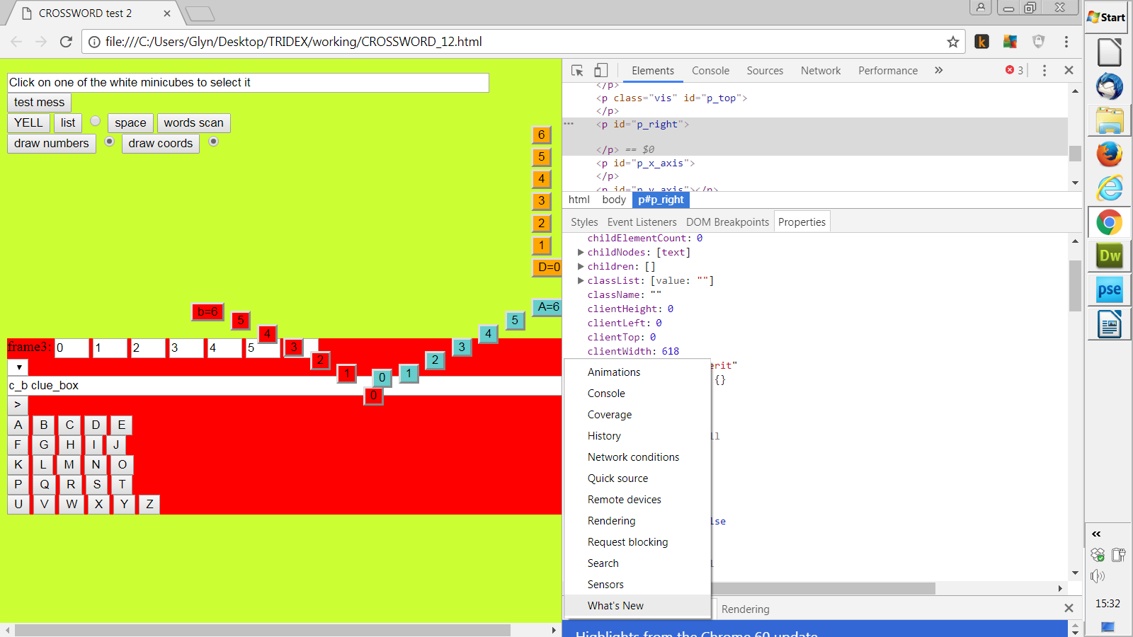
block1
block3
block4
Problem 2
Chrome had got to a state where it gave a red circle to indicate a program problem but didn't say what it was.
Solution found at

https://developers.google.com/web/tools/chrome-devtools/javascript/
Problem 3 Console log blank
Although I had commands in my program to say console.log('message') the message didn't appear on the screen.
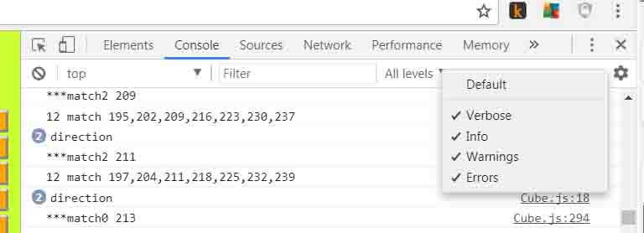
Selecting 'All levels' showed the levels without ticks. By clicking on them to get the ticks, as in the picture all the output appeared on the console.

